**Numerical Analysis Lab 5:**

**Name: Ali Hassaan Mughal**

**Reg: 173627**

**Task 1 [Regular Falsi (False Position) Method]:**

**Code:**

pi = 3.14;

xl = input('Enter Lower Guess: ');

xu = input('Enter Upper Guess: ');

tolerance = input('Enter tolerance value (Recommend: 0.001): ');

f = @(x) x - 2*sin(x^2);

oldxl =xl

oldxu = xu;

xr = 1000;

xoldr = 2*xr;1

while (abs((xr-xoldr)/xr) > tolerance)

xoldr = xr;

xr = xu - ((f(xu)*(xl-xu))/(f(xl)-f(xu)));

%xr

%f(xr)

if (f(xr) > 0)

if (f(xu)<0)

xl = xr;

elseif (f(xl)<0)

xu = xr;

end

end

if (f(xr)<0)

if f(xu)>0

xl = xr;

elseif f(xl)>0

xu = xr;

end

end

end

fprintf('The function value is: %.5f, root value: %.5f in range (%f - %f) with tolerance: %f\n', f(xr), xr, oldxl, oldxu,tolerance);

**Output:**

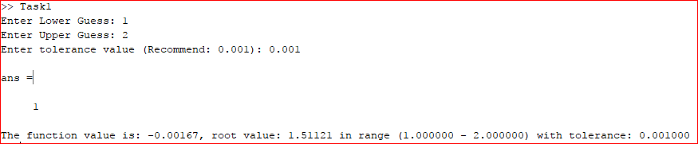

**Task 2 [Fixed Position Method]:**

**Code:**

xl = input('Initial Guess: ');

tolerance = input('Enter tolerance value (Recommend: 0.001): ');

f = @(x) 2*sin(x^2);

xoldl = 2*xl + 1;

while (abs((xl-xoldl)/xl)) > tolerance

xoldl = xl;

xl = f(xoldl);

end

fprintf('The root of function is x = %f with relative tolerance: %f', xl, tolerance);

**Output:**

